

**Automated Scoring for Short Questions with Deep Learning**

Submitted by

Michelle Vanessa

U1620071L

Project Supervisor

Assoc Prof. Hui Siu Cheung

School of Computer Science and Engineering

AY2019/2020



**SCE19-0305**

**Automated Scoring for Short Questions with Deep Learning**

Submitted in Partial Fulfilment of the Requirement for the Degree of Bachelor of Engineering (Computer Science)

Submitted by

Michelle Vanessa

U1620071L

Project Supervisor

Assoc Prof. Hui Siu Cheung

School of Computer Science and Engineering

AY2019/2020

# Abstract

This report proposes an improved approach of short answer questions scoring with deep learning, namely Siamese Bidirectional LSTM model with feature engineering. The project will conduct several experiments in order to improve the performance of the model. The scope of the questions is limited to Data Structures questions, and Mohler dataset is used in this experiment [1]. Eventually, the model will be deployed into a web server for data collection so that the model can be further trained and for self-practice purposes for computer science students.

# Acknowledgements

The author would like to express her gratitude to various individuals for their continuous assistance. This project would not have been possible without their support.

Firstly, the author would like to extend her deepest gratitude to Assoc Prof Hui Siu Cheung, the author’s final year project supervisor, for his guidance, encouragement, and constructive feedbacks throughout the year; to Akhil and Hao Anran for their continuous help and support; and to her parents who have supported her throughout her journey in Nanyang Technological University Singapore. Without them, this project would not have been as successful.

Lastly, the author wish to thank all her friends who have supported during her time in Nanyang Technological University Singapore and have been there for her when she needed encouragement. Without their faith in her, the author would not have been able to complete this project smoothly.

Table of Contents

Abstract 2

Acknowledgements 3

Table of Contents 4

List of Figures 6

Chapter 1: Introduction 7

1.1 Background 7

1.2 Motivation 7

1.3 Objectives 7

Chapter 2: Literature Review 8

Chapter 3: Existing Approach 10

3.1 Architecture 10

3.1.1 Embedding Layer 11

3.1.2 Vertical Layers 12

3.1.3 Concatenation Layer 13

3.1.4 Perceptron Layers 13

3.1.5 Output Layer 13

3.2 Deep Learning Models 13

3.2.1 Multilayer perceptron 14

3.2.2 Bidirectional LSTM Unit 14

3.3 Techniques 16

3.3.1 Batch Normalization 16

3.3.2 Dropout 16

3.4 Implementation 16

3.5 Training 16

3.6 Performance 16

Chapter 4: Experimental Evaluation 17

4.1 Dataset 17

4.2 Evaluation Metrics 17

4.2.1 Pearson Correlation Coefficient 17

4.2.2 Rooted Mean Square Error 17

4.2.3 Mean Absolute Error 17

4.3 Regularization 17

4.3.1 Weight Decay 17

4.3.2 Dropout 17

4.3.3 Batch Normalization 17

4.4 Question Demoting 17

4.5 Classification Model 17

4.6 Experiment Results 17

4.6.1 Regularization Results 17

4.6.2 Question Demoting 17

4.6.3 Classification Results 17

4.7 Analysis 17

Chapter 5: System Implementation 18

5.1 Methodology 18

5.2 System Use Case 18

5.3 Software Architectural Patterns 18

5.3.1 Web Application Framework 18

5.3.2 Database 18

5.3.3 System Interface 18

Chapter 6: Conclusion 19

Reference 20

List of Figures

Figure 1 Neural network graph generated by TensorBoard 11

Figure 2 Network architecture illustration 12

# Introduction

## Background

One of the main task of an educator is assess the understanding of their students. It can be measured through various assessments, which requires the educator to manually evaluate and grade the students’ responses. Time taken to do such activity depends on the open-endedness assessment since answers of open-ended questions have wider variety and are more subjective. Thus, multiple choice questions will take shorter time to score compared to essay questions. Scoring open-ended questions is susceptible to the grader’s subjectivity since there is no right or wrong. Automated grading system would help speed up scoring process and would be able to objectively grade student responses, thus eliminating the disadvantages of manual human scoring.

## Motivation

The education sector would benefit greatly from the automated essay scoring. Despite the fact that multiple choice questions scoring is now mostly done by machine, automated essay scoring is still not widely used even though it has been a research topic for some time now.

Most educational system still requires human to manually grade them, which consumes a lot of the educators’ time. With the help of the automated essay scoring, the grading process would be shortened [2], and educators would be able to reduce the time they spend doing so, and hence, increasing educators’ productivity on other activities. Moreover, the automated essay scoring has numerous advantages over manual scoring, such as objectivity and consistency.

* 1. Objectives

The objective of this project is to improve the existing short answer scoring approach, namely the Siamese Bidirectional LSTM model. The approach will be improved by fine-tuning the hyperparameters of the model and modifying the architecture of the model itself. However, the scope of the questions is limited only to Data Structures questions so that the answers could be more topic specific. It would later on be implemented in an educational setting, where it could help facilitate the scoring process of short-answered data structures related C programming questions, which, in this case, is to assist scoring of CX1007 Data Structures course as a part of students’ self-practice and performance evaluation.

# Literature Review

The essay grading problem has been addressed since years ago. One of the earliest approach to the problem is a method known as C-rater [3], which was developed by Educational Testing Service, also widely known as ETS, to measure students’ understanding based on their responses to short-answer questions. The method compares the syntactical characteristics of a sentence to a collection of correct ones. However, it is ignores the difference between passive and active voice, such as “you need two plants” and “ two plants are needed”.

More recent work has analysed the difference between corpus-based and knowledge-based measures of text similarity, and it was shown using Pearson’s correlation coefficient that corpus-based measure (Lexical Semantic Analysis) performs the best among other measures. It also introduced new technique which is similar to pseudo-relevance feedback to address the problem where there are more than one correct answer [4].

Although some works use Pearson’s correlation coefficient to compare student and reference answers, another experiment [5] showed that similarity measure using Cosine coefficient produce the best result. Cosine similarity measure has the highest accuracy rate compared to other measures, namely Jaccard coefficient and Dice coefficient.

One of the works that use Cosine similarity is the paragraph embeddings [6], which focused on short answer scoring. Answers are considered short “if its length approximately ranges from one phrase to one paragraph”. The word embedding vectors from the answer are combined using average, sum, or other methods, then, using the calculated vectors, new vectors are generated using paragraph embedding model. Cosine coefficient will be use to compare the paragraph vectors.

Another work proposed a new technique named question demoting [1]. The technique removes any words that occur in the question from both the student and gold standard answers. This technique is implemented to eliminate the chance that students who repeat words from the question in their answers get high score as it does not reflect their understanding in the topic.

Given the numerous methods, such as text similarity, question demoting, term weighting, length ratio, and word embeddings, some may affect the accuracy more than others. It is proven that alignment has the most significant influence. It measures text semantic similarity using text’s lexical and contextual meaning, which are represented by a word aligner. The rooted mean squared error (RMSE) increased by 5.7% when alignment is removed from the method. On the other hand, question demoting, length ratio, and term weighting improve the RMSE by 1.8%, 0.1%, and 0.2%, respectively [7].

RNNs are designed to retain information from previous time frames so that the patterns found in the past information can be used to predict the future patterns. Such method is known as long-term dependencies, and RNNs are designed to handle that. However, in practice, RNNs are unable to learn the dependencies, so a new approach, Long Short-Term Memory, was introduced to address this issue [8].

Long Short-Term Memory unit is a type of Recurrent Neural Network. the information in this unit goes back in time. It was first introduced in 1997 due to the inability of the conventional approach at that time to prevent the information going backwards to blow up or vanish [9]. To avoid the aforementioned problem, a forget gate was added to the unit so that insignificant information can be discarded.

# Existing Approach

The existing approach automates grading of short answer using Siamese bidirectional LSTM-based regression. This chapter discusses the deep learning methods utilised in the approach.

* 1. Architecture

This approach implements several neural network architectures which are combined, and together, they build the overall model architecture. The model consists of several layers, which are shown in Figure 1, the illustration of the layers in the network.

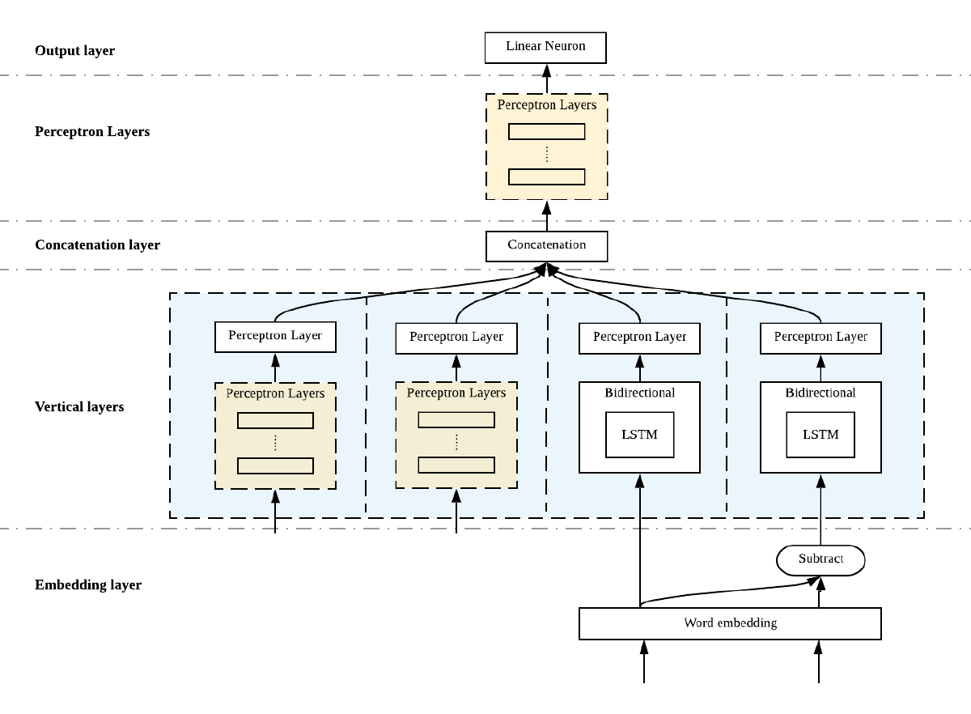

Figure 1 Network architecture illustration

Moreover, Figure 2 below is the neural network graph of the model as generated by the visualisation tool, TensorBoard.

Figure 2 Neural network graph generated by TensorBoard

* + 1. Embedding Layer

The first layer of the network is the embedding layer. This layer takes in a sequence of words as input, and each word will be mapped into high-dimensional vectors representing the respective words, also known as word embedding. In word embedding, similar words have similar values, and vector operations can be performed to obtain other words’ vector values.

This approach uses Word2Vec, which is one of the word embedding models. The model utilises the Skip-gram model and negative sampling [10]. The words are represented in such a way that the result of the vector operations reflects the linguistic patterns of the words. For example, the operation of the vectors “Madrid” – “Spain” + “France” will result a vector close to the vector of “Paris” [11].

The input of this layer will be the student answers and the reference answers, which will be the gold standard during the training of the model. On the other hand, the output of this layer will be the mapped 300-dimensional word vectors of the respective answers.

* + 1. Vertical Layers

This layer consists of several vertical layers that is independent from each other, and each has its specific functions. Following are the details of the layers as shown in Figure 2 from left to right, respectively.

* + - 1. Multilayer perceptron (feature engineering)

This layer consists of 2 layers of neurons, both of 50 neurons with sigmoid activation function. It receives 3 integers. The first integer is number of words of the reference answer, the second is number of the student answer, and the last one is number of words that exist both in the student and reference answers. To obtained these numbers, the answers are first tokenized using NLTK word tokenizer.

* + - 1. Multilayer perceptron (feature engineering)

This layer takes input of 5 set of data obtained from feature engineering. Feature engineering is a process where a certain data is produced by transforming raw data so that it could be used by the model to better learn the pattern of the given data [12]. In this case, length of the student answer (number of characters), ratio of the length of the reference answer and length of the student answer, number of words in the student answer, and the number of unique words in the student answer are used.

The input is then processed through 4 layers of 125 neurons with sigmoid activation function.

* + - 1. LSTM unit (reference answer)

This layer receives input from embedding layer, which is the embedded student answers. It will then propagated through a bidirectional LSTM unit and through a layer of 50 neurons with sigmoid activation function.

* + - 1. LSTM unit (comparison with student answer)

This layer architecture is the same as the previous layer. However, it has different input. Instead of receiving input straight from the embedding layer, this layer receives a vector of comparison between student answer and reference answer. The two sentences are compared using the distance of the two vectors. The distance is calculated using the equation below, where $R_{i}$ is the gold standard reference answer of question $Q_{i}$, and $A_{ij}$ is the student answer j of question $Q_{i}$. *v(X)* is the word vector of sentence *X*.

$$dist=v\left(R_{i}\right)-v(A_{ij})$$

Word2Vec groups similar words together [11], so words with similar meaning has similar vector values. Hence, the distance of the two vectors should be small if the sentences have similar meaning.

* + 1. Concatenation Layer

On this layer, the output from vertical layers are merged into one vector to be processed further in the following layers.

* + 1. Perceptron Layers

The concatenated vector is then propagated through a multilayer perceptron. The multilayer perceptron has 4 layers, where the first 3 layers consist of 125 neurons, and the last one consists of 25 neurons.

* + 1. Output Layer

The final layer of the network consist of 1 neuron with linear activation function. This neuron outputs the final predicted score.

* 1. Deep Learning Models

There are two main neural network architectures that are used in this approach, namely multilayer perceptron and bidirectional LSTM unit.

* + 1. Multilayer perceptron

Multilayer perceptron, a class of feedforward neural network, is a deep learning model that approximates some function by learning parameter so that it could generate the best result. Information flows through the layers of neurons, the first one, being called first layer, until the last one, the output layer. Between the first and output layer, there are more layers, called hidden layers. In contrast to Recurrent Neural Network, information in multilayer perceptron never goes backwards [13].

In this approach, multilayer perceptron is combined with other model to form the overall architecture. The output of the perceptron is concatenated with the output from other models before going through another chain of multilayer perceptron.

* + 1. Bidirectional LSTM Unit

The basic LSTM unit consists of a cell state that modulates information through the unit, and three gates (forget, input, and output) [8]. Following is the functions used in the unit, where $x(t)$ is the input and $h(t)$ the output.

* + - 1. Forget gate

Forget gate will determine whether the information should be removed or not. When it is 0, nothing will go through.

$$f\left(t\right)=σ(U_{f}^{T}x\left(t\right)+W_{i}^{T}h\left(t-1\right)+b_{f})$$

Where σ is sigmoid function.

* + - 1. Input gate
         1. Sigmoid layer

This layer will determine which values to update.

* + - * 1. Tanh layer

This layer will produce vector of new candidate values.

$$\tilde{C}\left(t\right)=ϕ\left(U_{c}^{T}x\left(t\right)+W_{c}^{T}h\left(t-1\right)+b_{c}\right)$$

Where φ is tanh function.

* + - 1. Output gate

This gate will allow memory cell to have effect on other neurons.

$$o\left(t\right)=σ(U_{o}^{T}x\left(t\right)+W_{o}^{T}h\left(t-1\right)+b_{o})$$

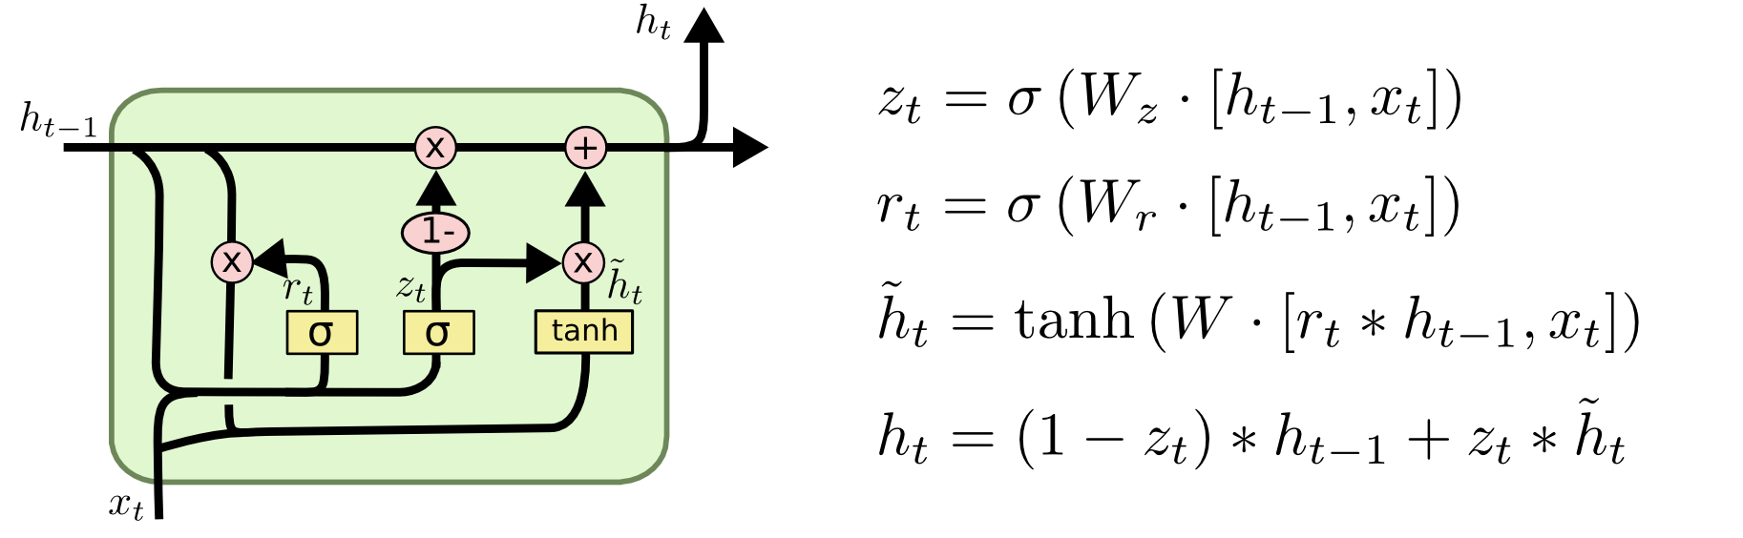

Figure 3 LSTM Unit

Afterwards, the cell state is updated using equation below, where ⊙ is element-wise product.

$$C\left(t\right)=\tilde{C}\left(t\right)⊙i\left(t\right)+C(t-1)⊙f(t)$$

The output value is calculated using the equation below.

$$h\left(t\right)=ϕ(C\left(t\right)⊙o\left(t\right))$$

However, this approach uses bidirectional LSTM, which means the neurons are split into two directions, forward and backward. This method will enables the effective usage of both past and present information for a specific time frame [14].

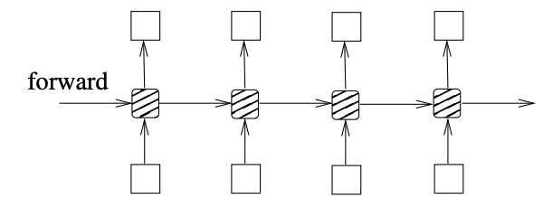

Figure 4 LSTM network

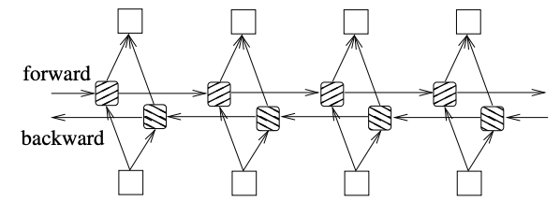

Figure 5 Bidirectional LSTM network

Bidirectional LSTM unit is used for two layers in this approach. Hence, this model also called a Siamese Bidirectional LSTM.

* 1. Techniques
     1. Batch Normalization
     2. Dropout

# Experimental Evaluation

* 1. Dataset

The experimental evaluation uses a dataset from an experiment conducted by Mohler, Bunescu, and Mihalcea [1]. The dataset consist of short-answered data structures questions.

* 1. Evaluation Metrics
     1. Pearson Correlation Coefficient

Pearson correlation coefficient measures the linear correlation of two variables. The coefficient ranges from -1 to 1, where 1 means the two variables are positively correlated and -1 negatively correlated.

The Pearson correlation coefficient $ρ$ of two variables $X$ and $Y$ is defined as below.

$$ρ_{X,Y}=\frac{s_{X,Y}}{s_{X}s_{Y}}$$

$$s_{X,Y}=\frac{1}{n-1}\sum_{k=1}^{n}{(X_{k}-\overline{X})(Y_{k}-\overline{Y})}$$

$$s_{X}=\sqrt{\frac{1}{n-1}\sum_{k=1}^{n}{{(X_{k}-\overline{X})}^{2}}}$$

Pearson correlation coefficient is calculated to evaluate the approach. However, since it only represents the linear correlation of the two vectors,

* + 1. Rooted Mean Square Error

Rooted mean square (RMSE) is the square root of the arithmetic mean of the squares of the difference between the two variables.

* + 1. Mean Absolute Error

Mean absolute error (MAE) measures the difference of two variables. It is the arithmetic mean of the absolute difference of the two variables.

* 1. Regularization
     1. Weight Decay
     2. Dropout
     3. Batch Normalization
  2. Question Demoting
  3. Classification Model
  4. Experiment Results
     1. Regularization Results
     2. Question Demoting
     3. Classification Results
  5. Analysis

1. System Implementation
   1. Methodology
   2. System Use Case
   3. Software Architectural Patterns
      1. Web Application Framework
      2. Database
      3. System Interface

# Conclusion

# Reference

|  |  |
| --- | --- |
| [1] | M. Mohler, R. Bunescu and R. Mihalcea, “Learning to Grade Short Answer Questions using Semantic Similarity Measures and Dependency Graph Alignments,” in *Proceedings of the 49th Annual Meeting of the Association for Computational Linguistics*, Protland, Oregon, 2011. |
| [2] | M. Zhang, “Contrasting Automated and Human Scoring of Essays,” in *R&D Connection*, vol. 21, Princeton, NJ: Research & Development Educational Testing Service, 2013, pp. 1-11. |
| [3] | C. Leacock and M. Chodorow, “C-rater: Automated Scoring of Short Answer Questions,” *Computer and Humanities,* vol. 37, pp. 389-405, 2003. |
| [4] | M. Mohler and R. Mihalcea, “Text-to-text Semantic Similarity for Automatic Short Answer Grading,” in *Proceedings of the 12th Conference of the European Chapter of the ACL*, Athens, Greece, 2009. |
| [5] | F. S. Pribadi, T. B. Adji, A. E. Permanasari, A. Mulwinda and A. B. Utomo, “Automatic Short Answer Scoring Using Words Overlapping Methods,” in *Engineering International Conference*, 2016. |
| [6] | S. Hassan, A. A. Fahmy and M. El-Ramly, “Automatic Short Answer Scoring based on Paragraph Embeddings,” *International Journal of Advanced Computer Science and Applications,* vol. 9, no. 10, pp. 397-402, 2018. |
| [7] | M. A. Sultan, C. Salazar and T. Sumner, “Fast and Easy Short Answer Grading with High Accuracy,” in *Proceedings of NAACL-HLT*, San Diego, California, 2016. |
| [8] | C. Olah, “Understanding LSTM Networks,” 27 August 2015. [Online]. Available: https://colah.github.io/posts/2015-08-Understanding-LSTMs/. [Accessed 10 March 2020]. |
| [9] | S. Hochreiter and J. Schmidhuber, “Long Short-Term Memory,” *Neural Computation,* vol. 9, no. 8, pp. 1735-1780, 1997. |
| [10] | Y. Goldberg and O. Levy, “word2vec Explained: Deriving Mikolov et al.'s Negative-Sampling Word-Embedding Method,” 2014. |
| [11] | T. Mikolov, I. Sutskever, K. Chen, G. Corrado and J. Dean, “Distributed Representations of Words and Phrases and their Compositionality,” *Advances in Neural Information Processing Systems 26,* 2013. |
| [12] | A. Casari and A. Zheng, Feature Engineering for Machine Learning, Sebastopol: O’Reilly Media, Inc., 2018. |
| [13] | I. Goodfellow, Y. Bengio and A. Courville, Deep Learning, MIT Press, 2016. |